Chart 1 – Bar Chart: Total Sales by Product Line

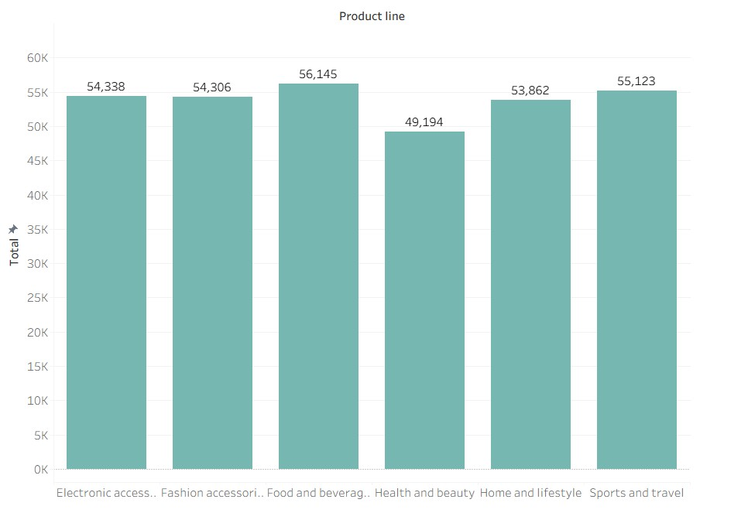

Chart 2 – Pie Chart : Payment Method Distribution

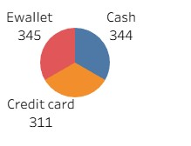

Chart 3: Stacked Bar Chart – Sales by City and Gender

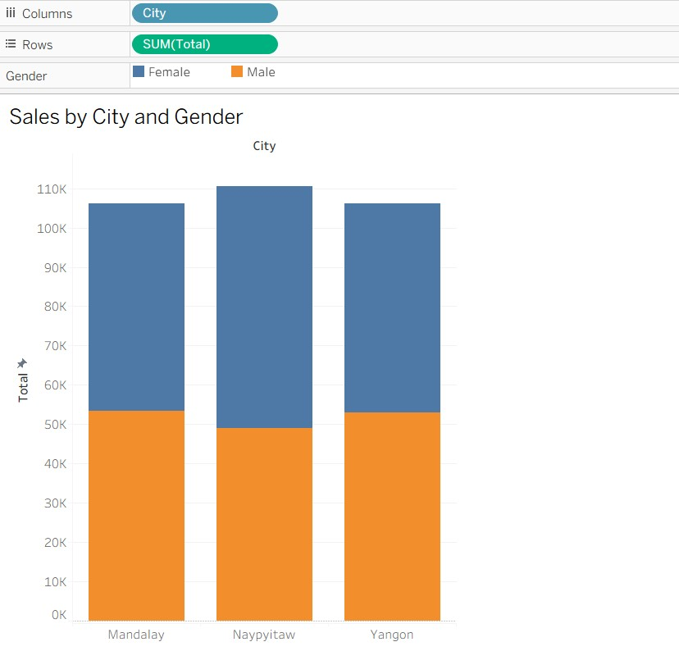

Chart 4: Line Chart – Total Sales Over Time

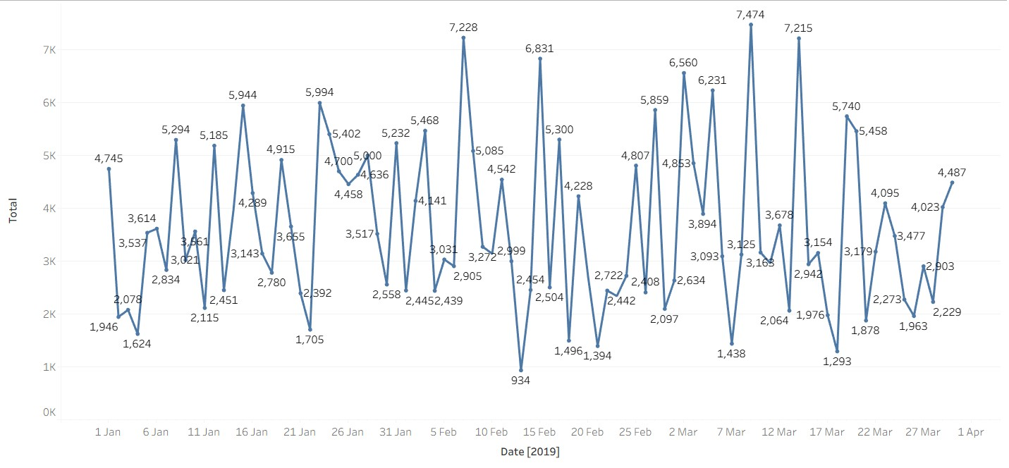

Chart – 5 : Bubble Chart – Gross Income by Product Line
